What is OSI and TCP/IP model.
OSI(Open Systems Interconnection) – Bu network qanaqa ishlashini tushuntiradigan 7 layerdan iborat asos hissoblanadi.( model,conceptual framework, reference model, descriptive guide)
OSI model ISO(International Organization for Standardization) tomonidan yaratilgan.
Bu model network qanaqa ishlashini tushuntirish uchun yaratilgan. Bu shunchaki 7 layerdan iborat qonun qoidalar(protocollar) jamlanmasi hissoblanadi. Hozirgi kunda bu modelning ishlab turgan working implementationi mavjud emas. Hozirgi kunda faqat ta’lim maqsadida o’qitiladi.
Because OSI is a mental framework, not an implementation.

OSI is used for learning
OSI explains networking cleanly by separation of concerns.
we don't actually use the OSI model in practice, but we use it constantly as a teaching and troubleshooting tool.
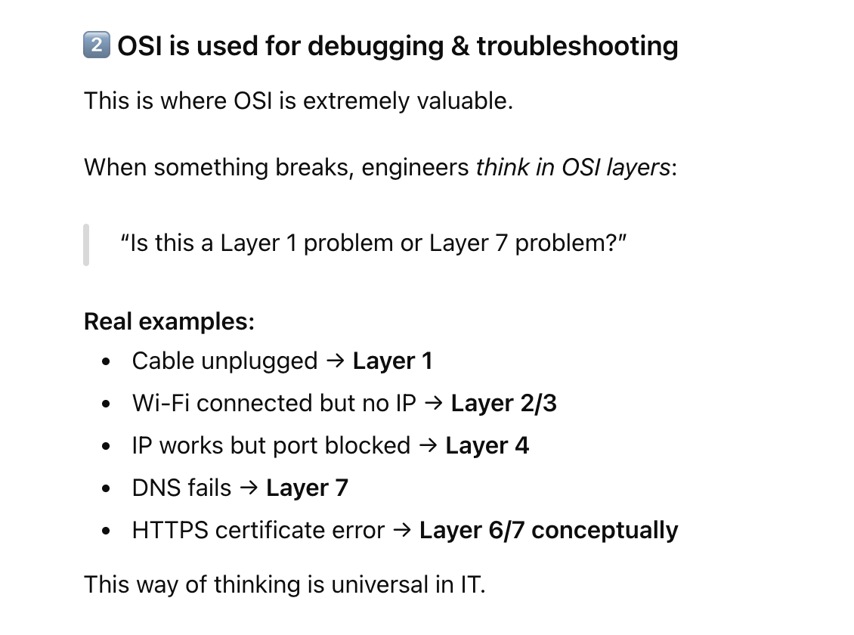

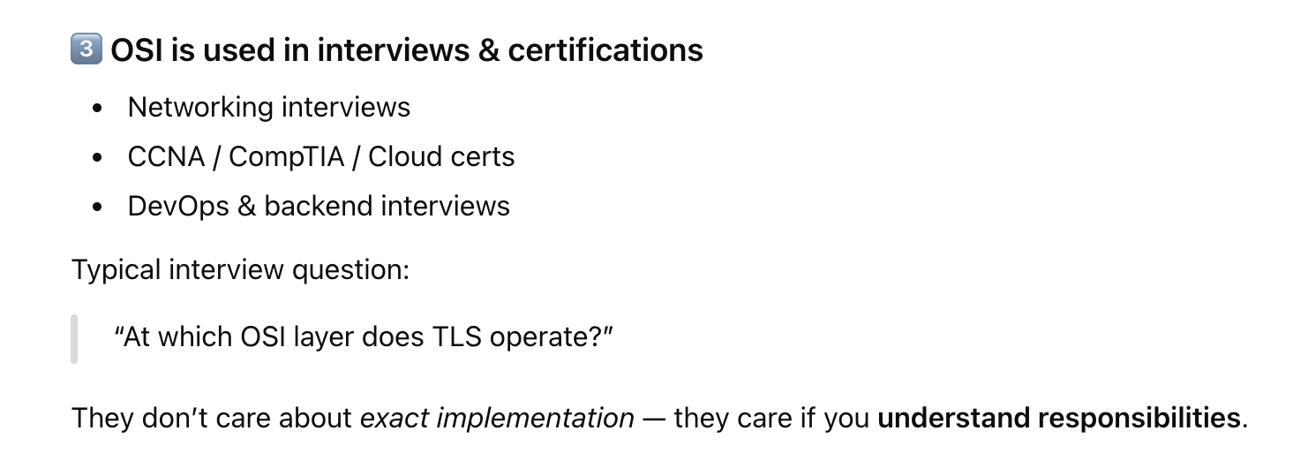
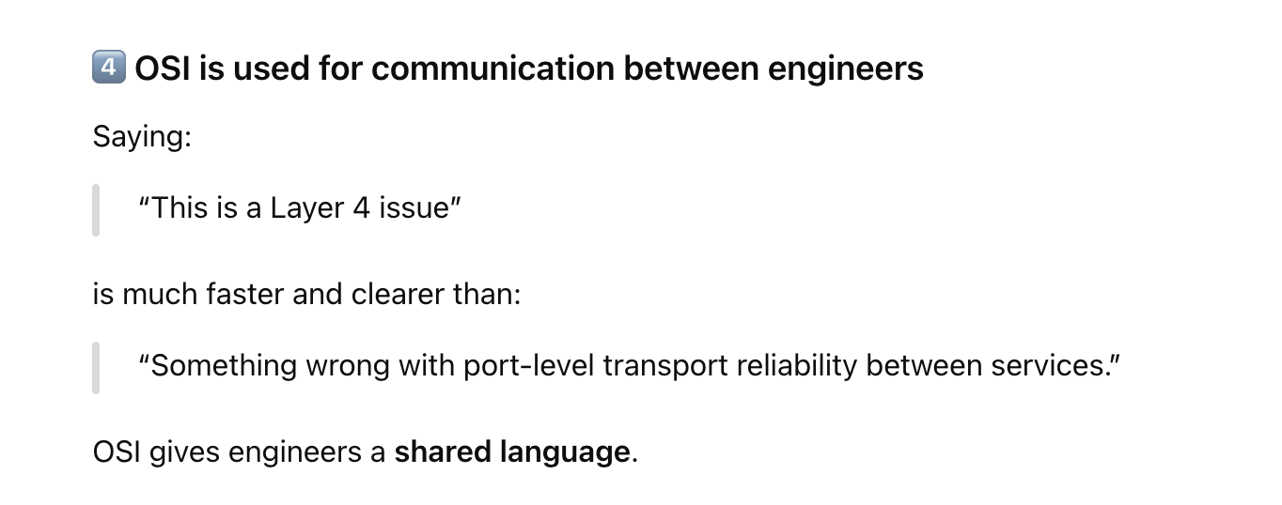
Vendor-Neutral Unlike TCP/IP which is tied to specific protocols, OSI is protocol-agnostic. It describes functions rather than specific implementations.
• Year introduced: 1978 (formal standard published in 1984 as ISO 7498)
• Goal: Create a universal networking standard so computers from different vendors could communicate.
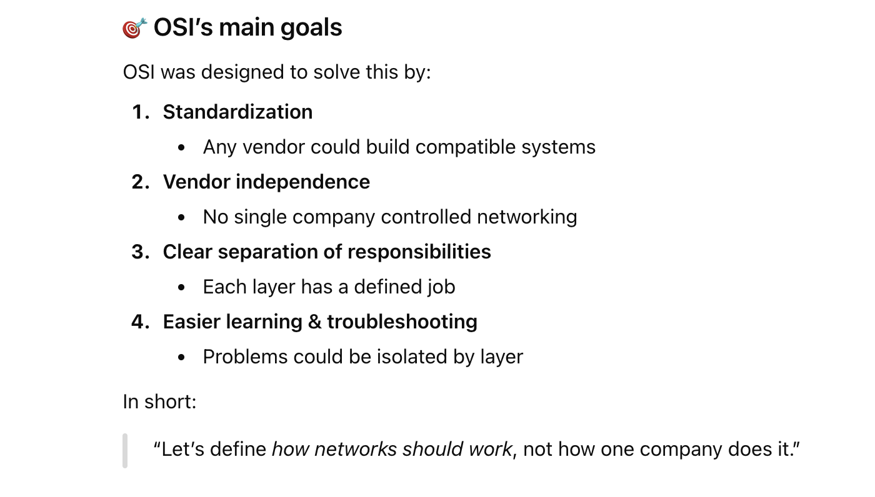
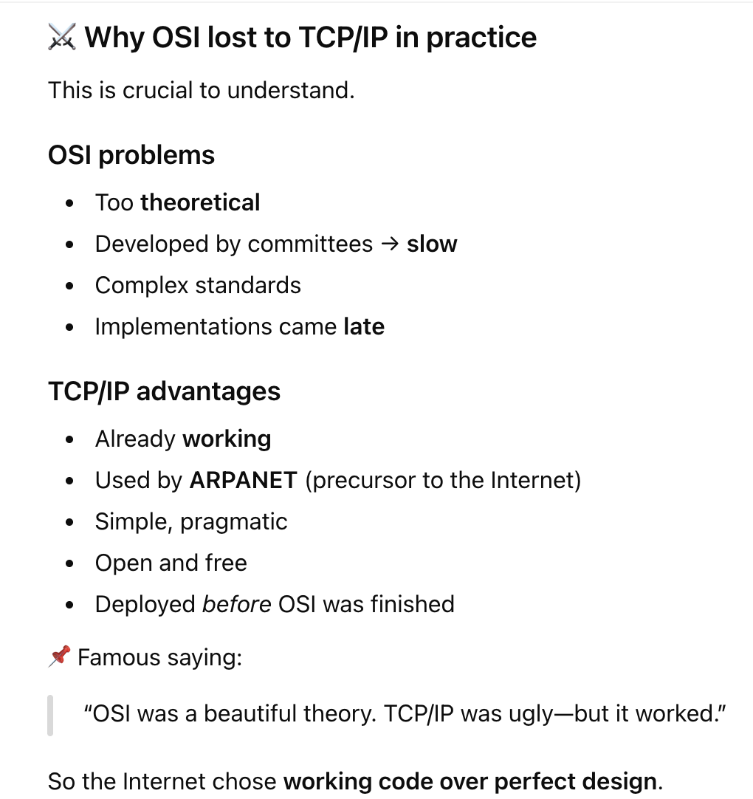

TCP/IP: The Protocol Suite That Built the Internet
TCP/IP(Transmission Control Protocol/Internet Protocol)
TCP/IP is the rulebook that allows computers all over the world to talk to each other reliably.
“TCP/IP was running code. OSI was paperwork.”
By the time OSI was standardized, TCP/IP already powered real networks.

TCP/IP: The Protocol Suite That Built the Internet

What is TCP/IP?
TCP/IP stands for Transmission Control Protocol/Internet Protocol. It's not just two protocols - it's actually a suite of protocols (a family of related protocols) that work together to enable communication across networks. When people say "TCP/IP," they're referring to this entire collection of protocols that make the internet work.
Think of it as a complete language system for computers to communicate. Just as human language has grammar, vocabulary, and rules for conversation, TCP/IP provides the rules and standards for how data is formatted, addressed, transmitted, routed, and received across networks.

The Core Components
IP (Internet Protocol) handles addressing and routing. It makes sure data packets can find their way from source to destination across multiple networks. Every device on a network gets an IP address (like 192.168.1.1 or a longer IPv6 address), which serves as its unique identifier.
TCP (Transmission Control Protocol) sits on top of IP and provides reliable, ordered delivery of data. It breaks data into packets, numbers them, sends them, and ensures they all arrive correctly and in order. If packets are lost, TCP resends them. It's like registered mail with confirmation.
But the TCP/IP suite includes many other protocols: UDP (faster but unreliable delivery), HTTP/HTTPS (web browsing), FTP (file transfer), SMTP (email), DNS (translating domain names to IP addresses), ARP, ICMP, and dozens more.

The History: Cold War Origins (1960s)
The story of TCP/IP begins during the Cold War. In the 1960s, the US Department of Defense was concerned about communication systems that could survive a nuclear attack. Traditional telephone networks were centralized - if key switching centers were destroyed, the entire system could fail.
ARPA (Advanced Research Projects Agency), a Pentagon research division, began exploring a radical idea: a decentralized network with no single point of failure. If one part of the network was destroyed, data could automatically find alternate routes.

ARPANET: The First Network (1969)
In 1969, ARPA created ARPANET, the first packet-switched network. The concept was revolutionary: instead of maintaining dedicated connections like phone calls, data would be broken into small "packets" that could travel independently through the network and be reassembled at the destination.
The first ARPANET connection was established on October 29, 1969, between UCLA and Stanford Research Institute. Legend has it that they tried to send the word "LOGIN" but the system crashed after "LO" - making "LO" the first message sent over what would become the internet.
Initially, ARPANET used a protocol called NCP (Network Control Program). It worked, but had significant limitations - it could only connect computers on the same network and lacked robust error handling.

The Birth of TCP/IP (1970s)
By the early 1970s, researchers realized they needed something better to connect different types of networks together. Two brilliant computer scientists, Vint Cerf (often called the "Father of the Internet") and Bob Kahn, began working on a solution.
1973: Cerf and Kahn presented their initial ideas for "internetworking" - connecting independent networks together. This is where the term "internet" (interconnected networks) originated.
1974: They published their landmark paper describing TCP, which initially combined what we now know as both TCP and IP into a single protocol.
1978: The protocol was split into two layers - TCP for reliable data transmission and IP for routing and addressing. This separation created more flexibility and is the architecture we still use today.

Testing and Refinement (Late 1970s - Early 1980s)
Throughout the late 1970s, TCP/IP was tested and refined on ARPANET alongside other experimental networks. Researchers connected different types of networks - satellite links, radio networks, and ground-based networks - proving that TCP/IP could truly enable internetworking.
Key moment in 1977: A demonstration successfully transmitted data across three different networks (ARPANET, packet radio, and satellite network) using TCP/IP, traveling from San Francisco to London and back. This proved the concept worked in the real world.

The Big Switch (1983)
January 1, 1983 - known as "Flag Day" - is considered the birthday of the modern internet. On this date, ARPANET officially switched from NCP to TCP/IP. Every computer on the network had to upgrade simultaneously. It was risky, but it worked.
From this point forward, TCP/IP was the standard protocol for ARPANET. The foundation for the internet as we know it was in place.

Why TCP/IP Succeeded
Free and Open: Unlike most networking technologies of the time, TCP/IP specifications were freely available. Anyone could implement it without paying licensing fees. The US government essentially gave it away.
Multiple Implementations: Different groups created their own TCP/IP implementations. UC Berkeley included TCP/IP in their BSD Unix, making it widely available to universities and researchers.
Simplicity and Pragmatism: TCP/IP was designed by engineers solving practical problems, not committees creating theoretical perfection. It was "good enough" and worked reliably.
University Adoption: Through the 1980s, universities connected to ARPANET and later to NSFnet (National Science Foundation Network) using TCP/IP. This created a generation of students familiar with the technology.
Email Killer App: Email became incredibly popular on these networks, giving people a compelling reason to connect.

The Internet Explosion (1990s)
1991: ARPANET was officially decommissioned. The internet had outgrown its origins and became a network of networks run by various organizations.
1993: The World Wide Web (invented by Tim Berners-Lee) became publicly available with the release of the Mosaic browser. HTTP (Hypertext Transfer Protocol) ran on top of TCP/IP, and suddenly the internet wasn't just for academics and researchers - it was for everyone.
1995: Commercial internet service providers exploded. Companies like AOL, CompuServe, and thousands of local ISPs brought internet access to homes. All of it ran on TCP/IP.

IPv4 and the Address Shortage
The original IP protocol (IPv4) used 32-bit addresses, allowing for about 4.3 billion unique addresses. In the 1980s, this seemed infinite. By the 1990s, engineers realized we'd run out of addresses as the internet grew exponentially.
IPv6 was developed in the 1990s with 128-bit addresses (allowing for 340 undecillion addresses - essentially unlimited). However, the transition has been slow. Today, both IPv4 and IPv6 coexist, with various technologies (like NAT - Network Address Translation) helping stretch IPv4 addresses.

TCP/IP Today
Today, TCP/IP is absolutely everywhere:
- Every website you visit uses HTTP/HTTPS over TCP/IP
- Your smartphone, laptop, smart TV, and IoT devices all use TCP/IP
- Cloud computing, streaming services, online gaming - all TCP/IP
- Even your car's navigation and your smart refrigerator use TCP/IP
It's estimated that there are over 5 billion internet users worldwide, with tens of billions of connected devices, all speaking the language of TCP/IP that Vint Cerf and Bob Kahn designed in the 1970s.

The Beautiful Irony
TCP/IP was initially funded by the military to create a communication system that could survive a war. Instead, it became the foundation for global commerce, social connection, entertainment, education, and human collaboration on an unprecedented scale. It connected the world in ways its creators never imagined.
The protocols designed on government and university computers in the 1970s, refined by researchers who could never have imagined smartphones or streaming video, still power the modern internet. Some details have been updated, new protocols have been added, but the fundamental architecture remains remarkably similar to what Cerf and Kahn designed over 50 years ago.
That's the story of TCP/IP - born from Cold War concerns, raised in academic networks, and ultimately becoming the invisible foundation of modern civilization.

https://claude.ai/chat/49b01337-8b67-4d2d-b7f9-2de9f11b2950
https://chatgpt.com/c/6948ef38-cc94-8328-9c85-91aa392fca1a
https://gemini.google.com/app/c383db59c51fd01d

TCP ikkita device orasida connection establish (aloqa) o’rnatish(handshake) uchun va data yetqazish uchun ishlatiladi. Bunda data packetlarga bo’linadi va har xil routelarga jo’natiladi.

